Business Question and Visualization Report

Date | 31 October 2026
Team ID | Not applicable – Individual Project
Project Name | EV Market Performance & Insights
Maximum Marks | 5 Marks

Visualization development in this project uses Tableau Public Desktop to turn EV market data into KPI cards, trend charts, comparisons, a geographic map and a Tableau Story. The project does not use Snowflake; the questions below are answered through Tableau worksheets and dashboard views.
Business Questions and Visualisation
Business Questions and Visualisation
The questions below are aligned to the visualisations visible in the submitted Tableau dashboard. Tableau aggregations are shown as formula examples; no Snowflake SQL was executed.
Project Business Questions and Visualisations (Tableau)

Note: Min 8 business question and visualisations Required inform of above

Business Questions, Tableau Measures and Visualisations
1. How have EV sales changed from 2021 to 2025?
Visualisation: Year-wise EV Sales Trend – Line chart.
Tableau measure / calculation: SUM([Annual Sales Units]) grouped by Year.
Observation from submitted view: The submitted chart rises from 400,000 in 2021 to 968,000 in 2025.
2. Which vehicle categories contribute more to EV sales?
Visualisation: EV Sales by Vehicle Category – Bar chart.
Tableau measure / calculation: SUM([Annual Sales Units]) grouped by Vehicle Category.
Observation from submitted view: The chart compares sales across the categories shown, including Sedan and SUV.
3. Which battery technologies have higher EV sales?
Visualisation: EV Sales by Battery Technology – Bar chart.
Tableau measure / calculation: SUM([Annual Sales Units]) grouped by Battery Technology.
Observation from submitted view: The submitted view shows NMC sales higher than LFP.
4. Which countries have higher EV sales?
Visualisation: EV Sales by Country – Bar chart.
Tableau measure / calculation: SUM([Annual Sales Units]) grouped by Country.
Observation from submitted view: The chart compares country-level sales across the markets displayed.
5. How are EV sales distributed geographically?
Visualisation: Global EV Sales by Country – Map.
Tableau measure / calculation: SUM([Annual Sales Units]) by Country; Country assigned a geographic role.
Observation from submitted view: The map provides a spatial comparison of countries represented in the view.
6. Which manufacturers contribute to EV sales?
Visualisation: EV Sales by Manufacturer – Pie chart.
Tableau measure / calculation: SUM([Annual Sales Units]) grouped by Manufacturer.
Observation from submitted view: The pie chart compares sales contribution across the displayed manufacturers.
7. How does customer rating vary with average vehicle price?
Visualisation: Customer Rating vs Average Vehicle Price – Scatter plot.
Tableau measure / calculation: AVG([Price INR]) and AVG([Customer Rating]); Manufacturer distinguishes marks.
Observation from submitted view: The scatter plot compares manufacturer marks across price and rating.
8. What is the overall EV market performance in the selected view?
Visualisation: KPI cards – Total EV Sales, Average Driving Range and Average Rating.
Tableau measure / calculation: SUM([Annual Sales Units]); AVG([Driving Range KM]); AVG([Customer Rating]).
Observation from submitted view: The screenshot displays 832,000 total sales, 480.6 km average range and 4.325 average rating.

Visualisation Screenshot Evidence
Dashboard overview and KPI cards
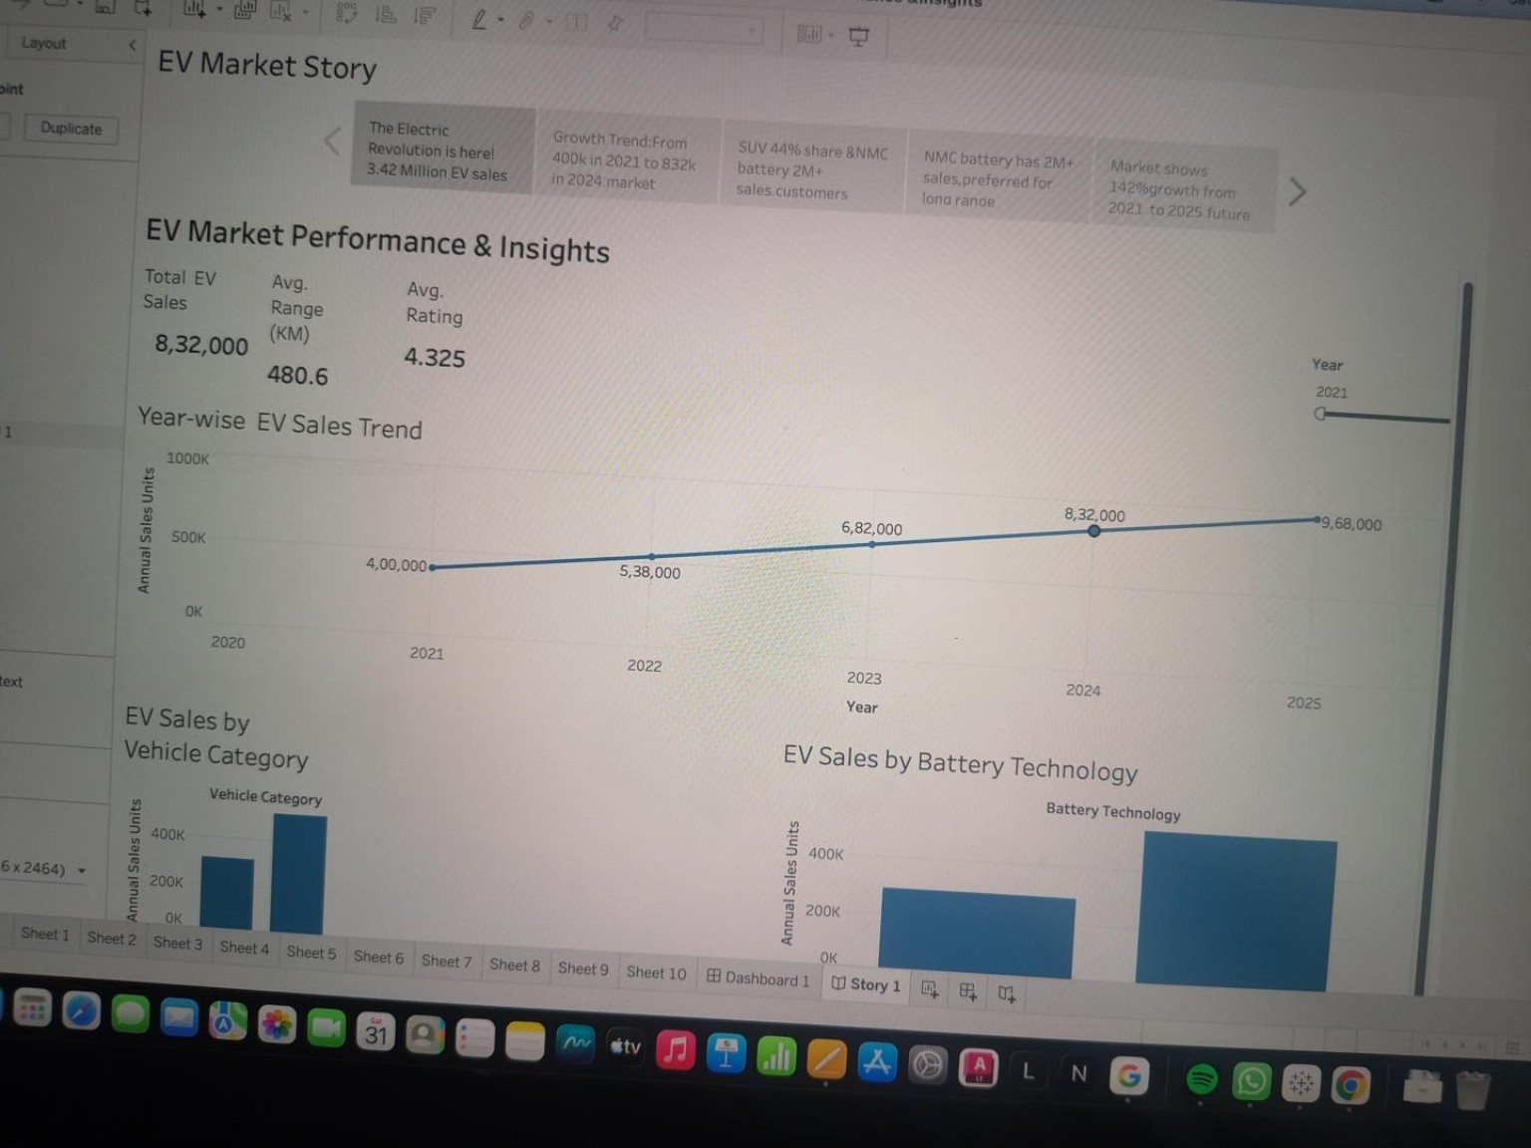
Year-wise trend, category and battery technology charts
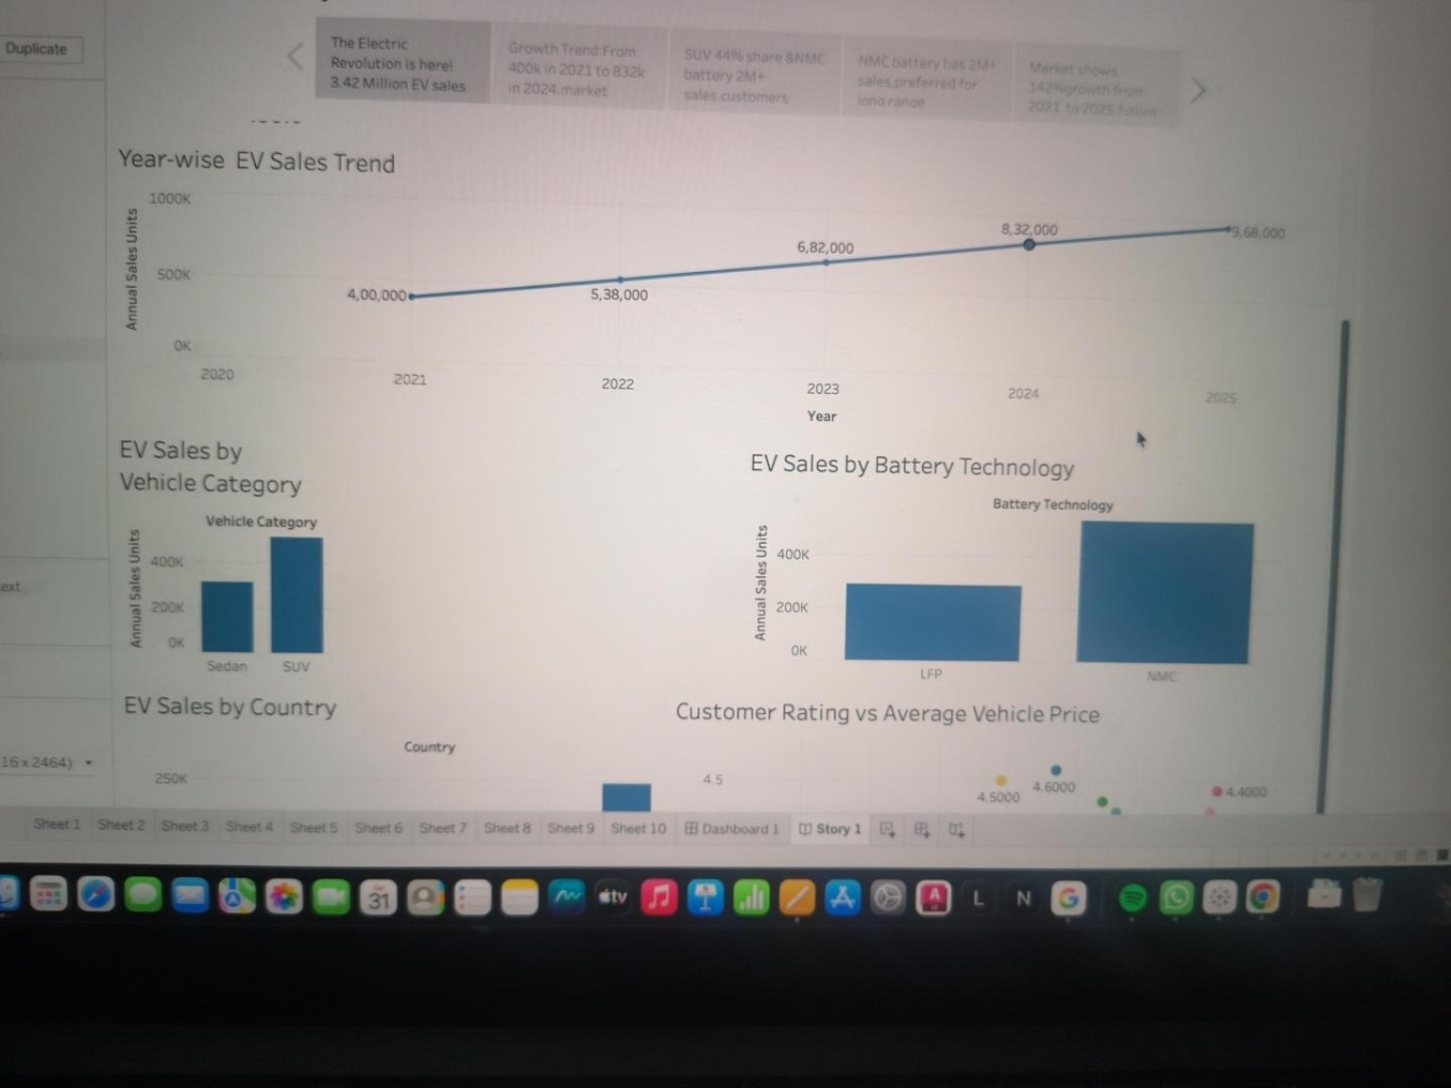
Country comparison and customer-rating versus price view
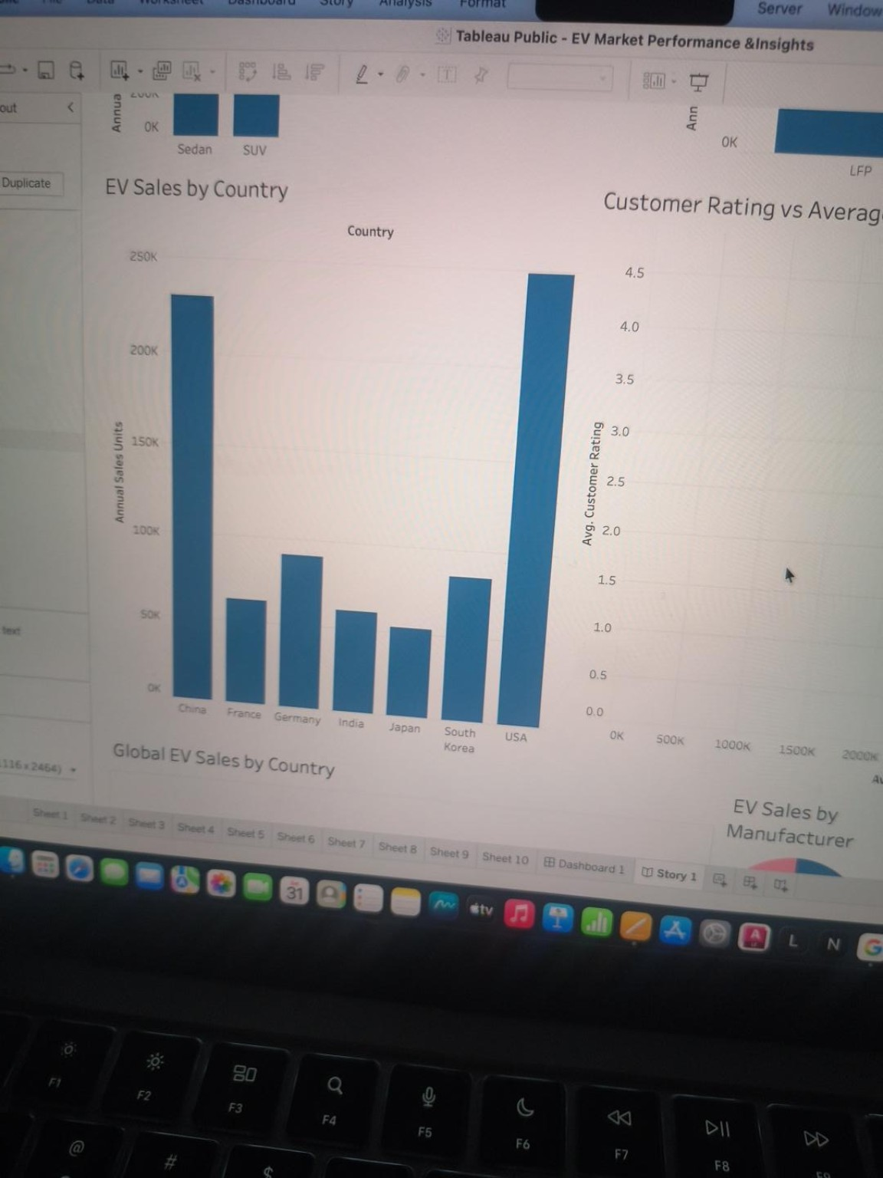
Scatter plot detail
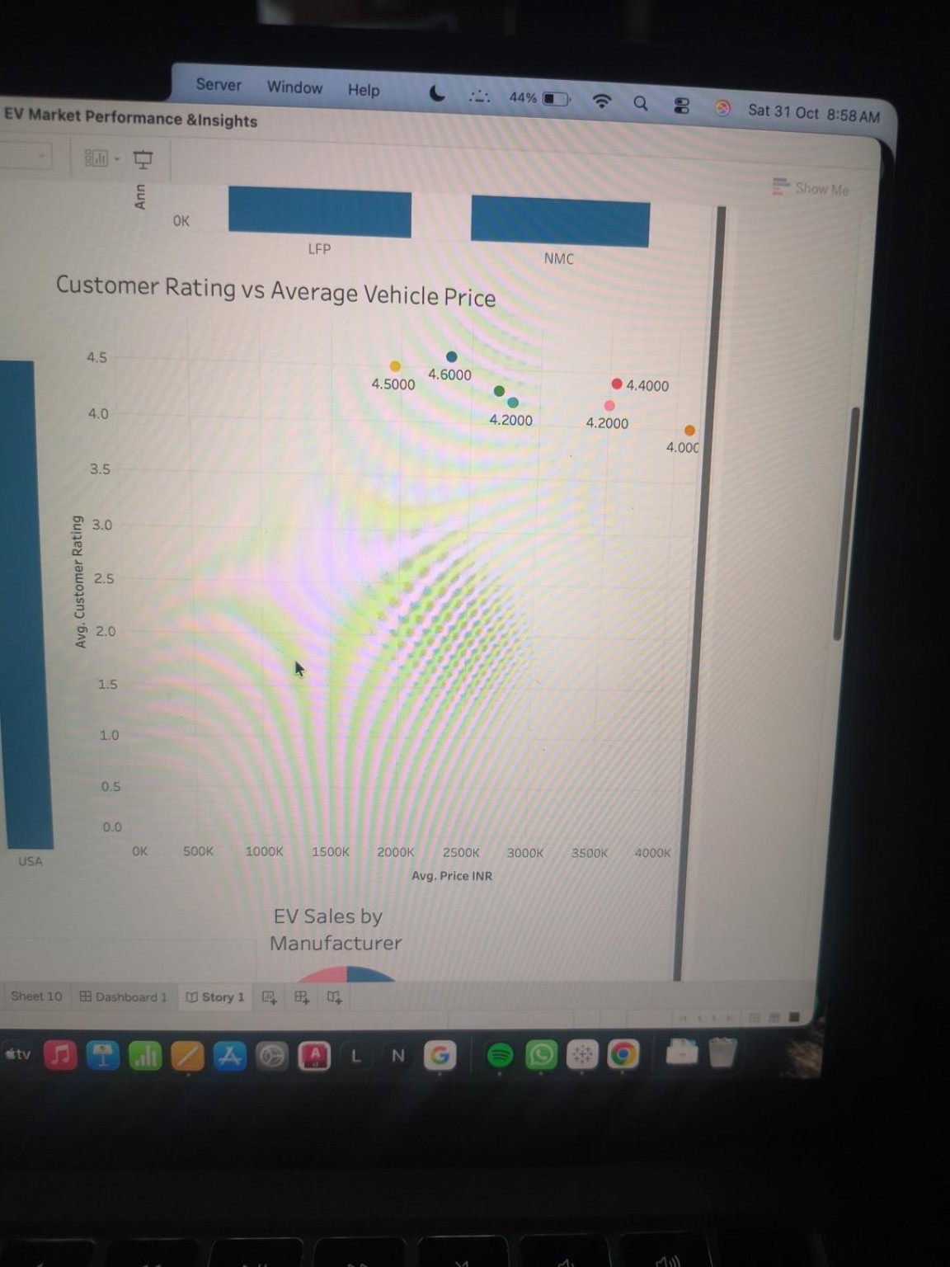
Country map and manufacturer contribution
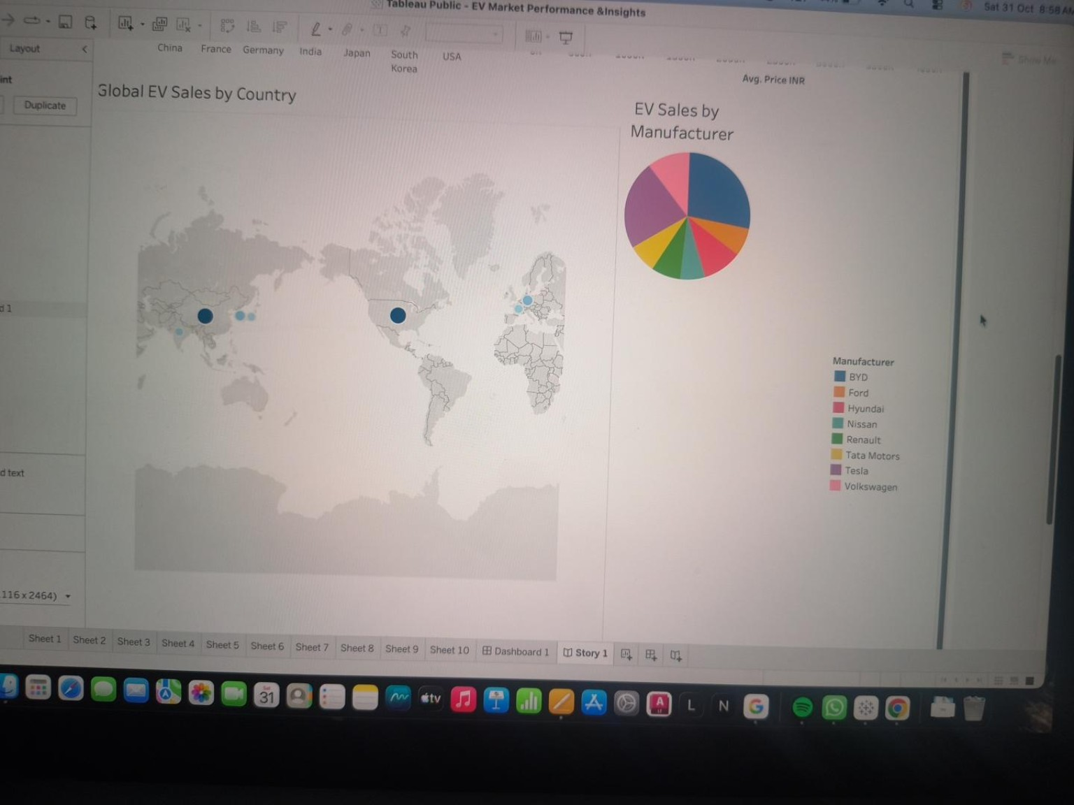
Implementation note: this report documents Tableau views, not Snowflake SQL queries. The exact CSV connected to the workbook must be confirmed because the available CSV file profile does not match all KPI values visible in the submitted screenshots.

